**1.HIBERNATE ARCHITECTURE:**

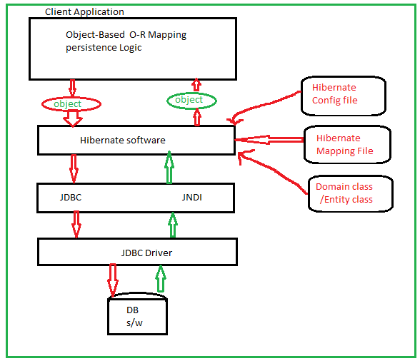

Hibernate can’t communicate to DB software Directly. To communicate with DB s/w , Hibernate internally uses the JDBC technology and helper technologies(JNDI,JTA).

1. **Hibernate Configuration file**:- It is xml file. This have the following information which is useful to hibernate and JDBC driver for establish connection with Database.
2. DB software name.
3. JDBC Driver class name.
4. DB URL
5. Username and password
6. …etc.
7. **Hibernate Mapping File**:- It is also xml file . This file have mapping details.

Bean /Domain class Name --🡪 Relation Name.

Properties of Bean/Domain class --🡪 columns of Relations.

…etc.

The client application have object based o-r mapping persistence logic . The application gives persistence method call to hibernate framework. The application give persistence logic to hibernate in the form of persistence object.

Hibernate frame work collect configuration details from Hibernate config file for establish connection for doing persistence operation.

Hibernate frame work will take mapping details(table name, col names) from Hibernate mapping file on the basis of persistence object.

Hibernate will prepare database dependent sql query based on tablename, col names and with persistence object provided data.

This sql query is submitted to DB s/w via JDBC Driver. The DB s/w execute the sql query. The query result will be given to Hibernate in the form of result set.

The hibernate create Domain/Entity class object in which Query result is placed. That Entity class object is given to Client application.